Highway Traffic Act
R.R.O. 1990, REGULATION 629
VEHICLES FOR THE TRANSPORTATION OF PHYSICALLY DISABLED PASSENGERS
Consolidation Period: From April 6, 2010 to the e-Laws currency date.
Last amendment: O. Reg. 133/10.
This is the English version of a bilingual regulation.
1. In this Regulation,
“accessible taxicab” means a van that is designed and intended to be used for the purpose of transporting persons who are physically disabled in wheelchairs and persons who are not physically disabled and that is licensed as a cab by a municipality; (“taxi accessible”)
“accessible urban transit bus” means a class of bus, while operated on a highway, that is designed and intended to be used for the purpose of transporting, for compensation, persons who are physically disabled and persons who are not physically disabled; (“autobus urbain pour le transport accessible”)
“Canadian Standards Association Standard D409-02” means that Standard, excluding the emergency exit requirements of section 6.4 of the Standard, and its updates up to and including October, 2004; (“norme D409-F02 de l’Association canadienne de normalisation”)
“physically disabled person” means a person unable, because of a mobility impairment, to use a regular transit facility; (“handicapé physique”)
“physically-disabled-passenger vehicle” means,
(a) a van or a bus operated on a highway,
(i) for the purpose of transporting, for compensation, physically disabled persons, or
(ii) by, for or on behalf of any person, club, agency or organization that holds itself out as providing a transportation service to physically disabled persons, for compensation or otherwise;
(b) an accessible urban transit bus; or
(c) an accessible taxicab; (“véhicule de transport adapté”)
“rear-entry accessible taxicab” means an accessible taxicab with a gross vehicle weight rating of not more than 2,700 kilograms that is equipped with a ramp at the rear, a rear door for wheelchair access and two rear side doors for ambulatory access. (“taxi accessible par l’arrière”) O. Reg. 184/96, s. 1; O. Reg. 346/02, s. 1; O. Reg. 49/05, s. 1.
2. (1) Every physically-disabled-passenger vehicle shall have at least one door for passenger access and an emergency exit door, located on different walls of the vehicle, and the emergency exit door shall be operable from both inside and outside the vehicle. R.R.O. 1990, Reg. 629, s. 2 (1).
(2) In the case of a physically-disabled-passenger vehicle used for the transportation of persons in wheelchairs, each of the doors referred to in subsection (1) shall have a wheelchair passageway not less than 762 millimetres wide. R.R.O. 1990, Reg. 629, s. 2 (2).
3. (1) Every physically-disabled-passenger vehicle shall,
(a) be equipped with an interior mirror designed to provide the driver with a view of the passengers;
(b) be equipped with lights arranged to illuminate all of the interior of the vehicle that shall be constantly lit during the loading or unloading of passengers;
(c) be equipped with a light above or beside each passenger access door to illuminate the loading equipment or step nosings, as the case may be, and such lights shall be constantly lit during the loading or unloading of passengers;
(d) be equipped with a means of securing in the open position, each passenger access door or emergency exit door that could be subject to unintentional closing during the loading or unloading of passengers;
(e) have an interior that is free of any sharp projections that may constitute a hazard to passengers;
(f) have permanently bonded to the floor, in the aisle and on the steps, floor covering that is fire-retardant, skid-resistant and wear-resistant rubber or equivalent material;
(g) have yellow or white step nosings;
(h) conform with Canada Motor Vehicle Safety Standard 302 regarding flammability;
(i) be equipped with at least one dry-chemical-type fire extinguisher,
(i) bearing the label of a recognized testing agency,
(ii) showing a rating of not less than 2-A:10-B:C, and
(iii) equipped with a pressure gauge indicating that the fire extinguisher is adequately charged,
contained in the extinguisher manufacturer’s bracket;
Note: On November 1, 2010, clause (i) is amended by adding “and” at the end. See: O. Reg. 133/10, ss. 1 (1), 3.
(j) be equipped with a unitized first aid kit in a sturdy, dustproof removable container containing,
(i) packets containing hand cleansers and gauze cleansing pads,
(ii) adhesive dressings, individually wrapped,
(iii) compress dressings,
(iv) eye dressing kits,
(v) gauze dressings,
(vi) gauze bandages,
(vii) adhesive tape,
(viii) triangular bandages,
(ix) rolled metal splint,
(x) one pair of scissors,
(xi) one pair of sliver tweezers, and
(xii) safety pins; and
Note: On November 1, 2010, subclause (xii) is amended by striking out “and” at the end. See: O. Reg. 133/10, ss. 1 (1), 3.
(k) be equipped with an axe or clawbar. R.R.O. 1990, Reg. 629, s. 3 (1).
Note: On November 1, 2010, clause (k) is revoked. See: O. Reg. 133/10, ss. 1 (1), 3.
(2) The fire extinguisher, first aid kit and axe or clawbar required by subsection (1) shall be mounted or secured in a location readily accessible to the driver and, if not in plain view, the location thereof shall be plainly marked. R.R.O. 1990, Reg. 629, s. 3 (2).
Note: On November 1, 2010, subsection (2) is amended by striking out “The fire extinguisher, first aid kit and axe or clawbar required by subsection (1)” at the beginning and substituting “The fire extinguisher and first aid kit required by subsection (1)”. See: O. Reg. 133/10, ss. 1 (2), 3.
4. (1) Every physically-disabled-passenger vehicle used for the transportation of persons in wheelchairs shall display the international symbol of accessibility in a clearly visible position on the rear of the vehicle and on the front of the vehicle in a position other than on the windshield. R.R.O. 1990, Reg. 629, s. 4 (1).
(2) The symbol of accessibility required by subsection (1) shall be a rectangle,
(a) with a height of not less than fifteen centimetres and width of not less than fifteen centimetres; and
(b) consisting of a symbol in white on a blue background as illustrated in the following figure:
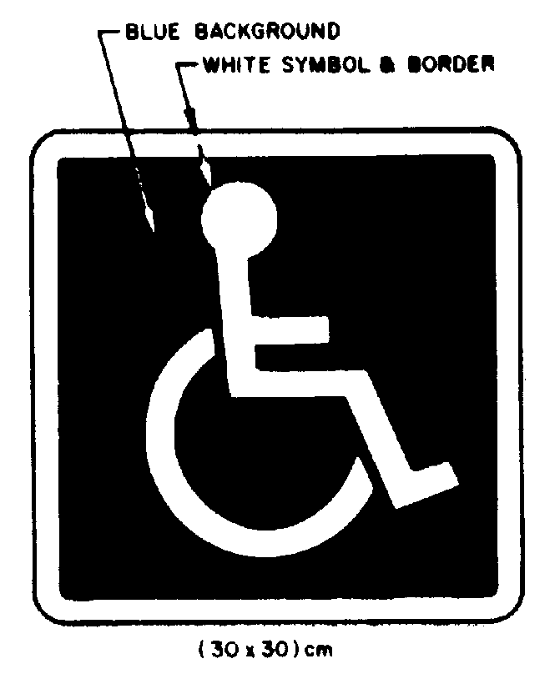
R.R.O. 1990, Reg. 629, s. 4 (2).
5. (1) Every loading ramp used on a physically-disabled-passenger vehicle shall,
(a) have a skid resistant surface;
(b) have raised edges of sufficient height to prevent a wheelchair from rolling off the edge of the ramp during the loading or unloading of passengers; and
(c) be secured by means other than a support or lug in the door while the vehicle is operated on a highway. R.R.O. 1990, Reg. 629, s. 5 (1).
(2) Every power lift used on a physically-disabled-passenger vehicle shall,
(a) have a skid resistant platform surface;
(b) have the sides of the platform fitted with guards extending the full length on each side and of sufficient height to prevent a wheelchair from rolling off the platform during vertical operation of the lift;
(c) have a retractable lip on the outer edge of the platform of sufficient height to prevent a wheelchair from rolling off the platform during vertical operation of the lift;
(d) be secured by means other than a support or lug in the door while the vehicle is operated on a highway; and
(e) be capable of raising and lowering a minimum weight of 275 kilograms. R.R.O. 1990, Reg. 629, s. 5 (2).
6. (1) Every physically-disabled-passenger vehicle used for the transportation of persons in wheelchairs shall be equipped with wheelchair securement devices that limit the forward, backward, rotational, lateral and vertical motion of every wheelchair in the vehicle at the points of contact of the wheelchair with the vehicle while the vehicle is in normal operation. R.R.O. 1990, Reg. 629, s. 6 (1).
(2) For the purpose of subsection (1), normal operation includes full throttle acceleration and maximum braking and cornering. R.R.O. 1990, Reg. 629, s. 6 (2).
(3) Every wheelchair securement device in a physically-disabled-passenger vehicle shall be,
(a) securely anchored to the vehicle; and
(b) capable of withstanding a load in any direction of not less than 11120 newtons for a period of ten seconds. R.R.O. 1990, Reg. 629, s. 6 (3).
(4) Where more than one wheelchair securement device is used to secure a wheelchair in a physically-disabled-passenger vehicle, clause (3) (b) applies to the combination of devices used and not to each single device. R.R.O. 1990, Reg. 629, s. 6 (4).
7. (1) Every physically-disabled-passenger vehicle shall be equipped with a pelvic-type occupant restraint assembly, securely anchored to the vehicle, for each seat in the vehicle used for the carriage of physically disabled persons. R.R.O. 1990, Reg. 629, s. 7 (1).
(2) Every designated wheelchair position in a physically-disabled- passenger vehicle shall, in addition to the devices required by section 6, be equipped with an occupant restraint assembly,
(a) securely anchored to the vehicle; or
(b) capable of securing a wheelchair occupant to the wheelchair by encircling both the occupant and wheelchair. R.R.O. 1990, Reg. 629, s. 7 (2).
(3) Every occupant restraint assembly in a physically-disabled- passenger vehicle shall be capable of withstanding a load in any direction of not less than 11120 newtons for a period of ten seconds. R.R.O. 1990, Reg. 629, s. 7 (3).
8. (1) Physically-disabled-passenger vehicles with bodies or chassis manufactured on or after the 1st day of January, 1986 are prescribed as a class of vehicle for the purpose of subsection 102 (3) of the Act. R.R.O. 1990, Reg. 629, s. 8 (1).
(2) The standards prescribed for a class of vehicle referred to in subsection (1) are those set out in the Canadian Standards Association Standard D409-M84. R.R.O. 1990, Reg. 629, s. 8 (2).
(3) Equipment conforming with the Canadian Standards Association Standard D409-M84 is prescribed and required for use in all vehicles of the class referred to in subsection (1). R.R.O. 1990, Reg. 629, s. 8 (3).
(4) Despite subsections (2) and (3), for rear-entry accessible taxicabs with bodies or chassis manufactured on or after June 30, 2005,
(a) the prescribed standards are those set out in the Canadian Standards Association Standard D409-02; and
(b) equipment conforming with the Canadian Standards Association Standard D409-02 is prescribed and required for use. O. Reg. 49/05, s. 2.
(5) Despite subsections (2) and (3), for rear-entry accessible taxicabs with bodies or chassis manufactured on or after January 1, 1986 and before June 30, 2005 that, had the Canadian Standards Association Standard D409-02 been in force at the time of their manufacture, would have conformed with that Standard,
(a) the prescribed standards are those set out in the Canadian Standards Association Standard D409-02; and
(b) equipment conforming with the Canadian Standards Association Standard D409-02 is prescribed and required for use. O. Reg. 49/05, s. 2.
(6) Despite subsections (2) and (3), rear-entry accessible taxicabs with bodies or chassis manufactured on or after January 1, 1986 and before June 30, 2005, other than those described in subsection (5), are exempt from the emergency exit requirements of section 6.9.1 of the Canadian Standards Association Standard D409-M84. O. Reg. 49/05, s. 2.
9. Section 2, clauses 3 (1) (h) and 5 (2) (e) do not apply to vehicles,
(a) that were used for the transportation of physically disabled persons prior to the 1st day of September, 1981; and
(b) for which a letter of exemption has been issued by the Ministry upon the application of the operator of the vehicle. R.R.O. 1990, Reg. 629, s. 9.
10. Public vehicles equipped with air-ride or torsion-bar suspension, reclining seats, baggage capacity separated from the passenger cabin, motive power that is mounted to the rear of the front axle, and commonly known as intercity motor coaches, that are designed or modified for the purpose of transporting physically disabled persons in wheelchairs and equipped with a lift, are designated as a class of vehicle and that class is exempt from section 2, clause 5 (2) (b) and section 8. R.R.O. 1990, Reg. 629, s. 10.
11. (1) An accessible urban transit bus is prescribed as a class of vehicle to which subsection 102 (3)of the Act applies. O. Reg. 184/96, s. 2.
(2) An accessible urban transit bus shall be used only to provide public transportation as defined in subsection 93 (1) of the Public Transportation and Highway Improvement Act. O. Reg. 184/96, s. 2.
(3) An accessible urban transit bus shall have,
(a) a minimum length of 9.144 metres and a bus chassis as originally provided by the bus manufacturer;
(b) at least two passenger doors on the right side, the front door being at least 762 millimetres wide and the other door being at least 813 millimetres wide;
(c) at least two readily accessible spaces designated for personal mobility devices;
(d) a system for securing personal mobility devices consisting of devices anchored to the bus or of compartments, or a combination of both, that limit the forward, backward, rotational, lateral and vertical motion of every personal mobility device in the bus at its points of contact with the bus while it is in normal operation, including full throttle acceleration and maximum braking. O. Reg. 184/96, s. 2.
(4) An accessible urban transit bus shall have either,
(a) a power lift to load a passenger mobility device and passenger onto the bus; or
(b) a mostly level floor that, either by design or by the use of a “kneeling” feature, is approximately at the level of a typical urban curbside or bus passenger platform during loading or unloading of passengers and is equipped with a ramp having a slope of no more than 4 to 1 to allow passengers to bridge the gap between the bus and the curbside or platform. O. Reg. 184/96, s. 2.
(5) The specifications for physically disabled passenger vehicles set out in section 2, clauses 3 (1) (d) and (k) and subsection 3 (2) in relation to the axe and clawbar, and sections 6, 7 and 8 do not apply to accessible urban transit buses. O. Reg. 184/96, s. 2.
Note: On November 1, 2010, subsection (5) is revoked and the following substituted:
(5) Section 2, clause 3 (1) (d) and sections 6, 7 and 8 do not apply to accessible urban transit buses. O. Reg. 133/10, s. 2.
See: O. Reg. 133/10, ss. 2, 3.
12. (1) Physically disabled passenger vehicles with bodies or chassis manufactured on or after April 1, 1996, with a gross vehicle weight rating of not more than 2,700 kilograms and equipped with not more than two wheelchair securement devices are designated as a class of vehicle that is exempt from subsection 2 (2) and the door opening requirements in section 6.9.1 of the Canadian Standards Association Standard D409-M84. O. Reg. 326/97, s. 1.
(2) A physically disabled passenger vehicle referred to in subsection (1) shall have,
(a) a door for passenger access with a clear opening of not less than 762 millimetres wide; and
(b) an emergency exit door with a clear opening of not less than 724 millimetres wide. O. Reg. 326/97, s. 1.
13. (1) Accessible taxicabs that are manufactured by the London Taxis International division of Manganese Bronze Holdings PLC, bear the model name TXII and are equipped with a ramp and two rear side access doors are designated as a class of vehicle that is exempt from clause 5 (1) (b), section 8 and subsection 12 (2). O. Reg. 346/02, s. 2.
(2) Subsection (1) only applies if the vehicles described in that subsection conform to the standards required under the Motor Vehicle Safety Act (Canada) and bear the National Safety Mark referred to in that Act. O. Reg. 346/02, s. 2.
14. Sections 2 and 12 do not apply to rear-entry accessible taxicabs with bodies or chassis manufactured on or after January 1, 1986. O. Reg. 49/05, s. 3.

